Toby Bluck

BLU16274423

Word Count

2189

SCDT45 CW2

Creating an Interactive Program

Table of Contents

Requirements – 2

Introduction: 2

User requirements & System requirements: 2

Data requirements: 3

UI & UX requirements: 3

Testing of 3D Interactive app – 4

Functionality testing 4

Performance testing 6

User experience testing by Ashley Tuft 7

Amendments made from the UX testing: 9

End-user documentation – 10

Main menu 10

Help menu 10

Exit Button 10

Choice menu (plant cell) 11

Plant cell 11

Pause menu 12

Choice menu (sodium bicarbonate) 12

Sodium Bicarbonate 13

Choice menu (Sulfuric Acid) 13

Sulfuric Acid 14

Choice menu (Serial circuit) 14

Serial circuit (no light) 15

Serial circuit (lights on) 15

Choice menu (Parallel circuit) 15

Parallel circuit (no light) 16

Parallel circuit (lights on) 16

Evaluation– 17

Functional Requirements 17

Non-Functional Requirements 18

Annotated code to achieve this – 19

Main menu 19

Sub menu/choice menu 19

Fade transition 20

Rotating object/s 20

Audio script 20

Toggle lights on/off 1 21

Lights on/off 2 21

Pause menu 22

Evaluation of tools and methodologies – 23

Tools – 23

3ds Max 23

Substance Painter 23

Unity 24

Methodologies – 24

References 25

# Requirements –

## Introduction:

A high school has requested an interactive application to be made for the secondary school student so they can explore models within the different sciences and interact with them. The interactive app must be user friendly and have a simple but clean interface for the students to easily grasp.

## User requirements & System requirements:

Functions & workflow – the functions that need to be included within the application that has been proposed is.

Viewing the model, this would be done by panning around the model to see all areas of any given model that has been provided.

Interaction with the model, for the circuit models this would be done by being able to toggle the lights on/off while being able to view the model alongside it.

Menu navigation with buttons to switch the screen that is currently being viewed and the ability to backtrack from that step or further steps back to the start.

Clear way to quit the application once use has finished with the user/s.

To transition from one screen to another without causing issues or hindering the users experience.

Overall performance of the application is reliable and steady, making sure the user doesn’t have to wait long period of times between screen transition as well as making sure when view and interacting with the models there is no decreases is stability or overall speed of the application.

## Data requirements:

No data is required within this application from the user, only the information that is within the application should be used and no more information is needed within the application. (Hunt et al., 2016)

## UI & UX requirements:

UX requirements for this application falls into 4 sections.

Useful – all the content within the application fulfils the purpose of the requirements set out and that it is relevant to the student’s educational needs.

Usable – the overall use of the application must be intuitive and simple for all the users to grasp and use to its fullest extent.

Desirable – all images and models within the application need to evoke some form of emotion and/or appreciation, this can be with a colourful and well textured model etc.

Findable – within the application all information and resources need to be easy to find and navigate. (User Experience Basics | Usability.gov, n.d.)

UI requirements for this application fall into 3 sections

Keep interface simple – the interfaces within the application are all clear and concise with what they should do and avoid any unnecessary elements to prolong the functionality of the app. Avoid using any complicated jargon on buttons or information within the application.

Consistency with UI elements – throughout the whole application the there should be a common theme with all elements within the interfaces. Consistency will help users feel more comfortable with the application and create a reoccurring pattern to help benefit the overall user experience.

Strategic use of colour and textures – within the application use of colour and changing colour for UI elements will convey whether they are functional and whether something has worked when interacting with elements.

# Testing of 3D Interactive app –

## Functionality testing

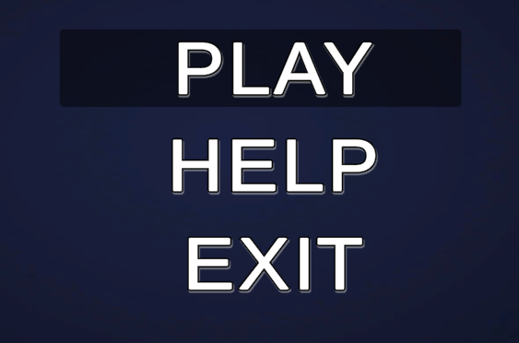

Testing the functionality of the hover over buttons, which works over the 3 buttons, so no fixes are needed.

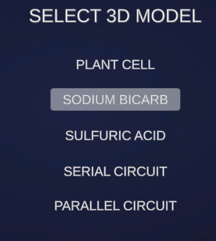

Checking the functionality of the hover and selection for buttons on the sub menu, which all work so no fixes are needed.

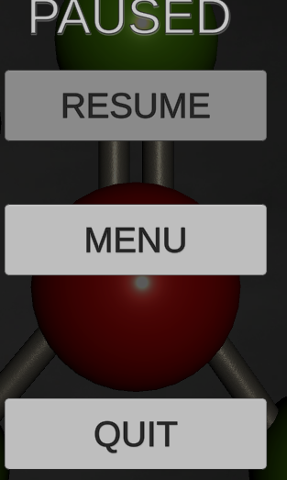

Checking of the hover and overall functionality on the buttons within the pause menu which all work, so no fixes to be deployed.

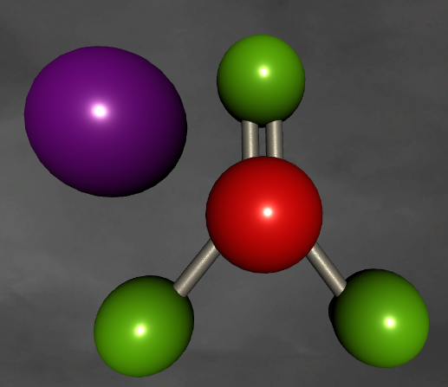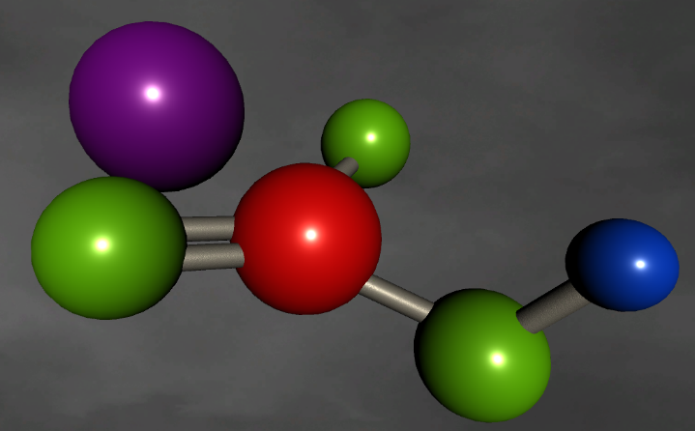

Testing the functionality of the interactions with the models through the interactive app which all work and function as expected.

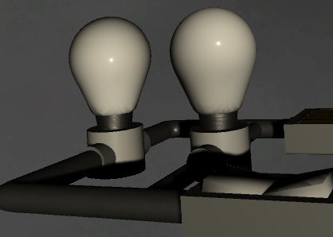 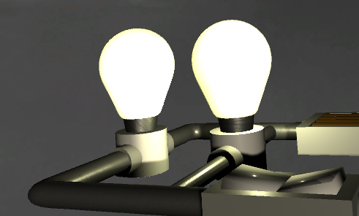

Testing functionality of the light/s within the circuit’s models, which work as expected.

## Performance testing

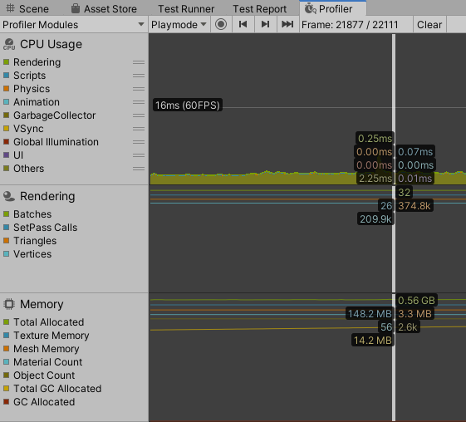

Using the Profiler in Unity analysis window allows you to record and benchmark performance over the application runtime as it go through scenes and loads assets and scripts, as you can see the FPS is relatively low when not being interacted with but scales based on rotational speed of the model. Furthermore, the overall load placed on the RAM is quite minimal as its 0.56GB in size as well the overall strain on the CPU is miniscule due to the response speed (0.25ms for rendering), however this will vary CPU to CPU but wouldn’t scale exponentially.

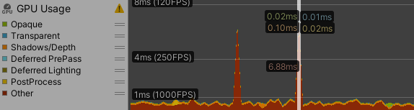

With the GPU usage this has been situated on a spike when the model was being rotated quickly, which you can see that the “Other” section was the highest response time 6.88ms and just higher than 120FPS. This will scale similar to the CPU.

## User experience testing by Ashley Tuft

Usable –

-The starting menu is simple and straight forward, with the 3 options being play, help, and exit.

After clicking play, you are then greeted with various scientific terminology.

Plant Cell, Sodium Bicarb (Sodium Bicarbonate), Sulphuric Acid, Serial Circuit and Parallel Circuit.

-Viewing of the models is intuitive as you click LMB/Mouse 1 in order to rotate the model, this required no prior knowledge as its one of the most used controls on PC.

This is however also mentioned in the help section.

-Changing models is straight forward as you hit the ESC (Escape Key) in order to access the menu again, which is a commonly used key in games and applications.

-The "Help Menu" is clear and brief, this is good for users who may struggle to read complicated sentences.

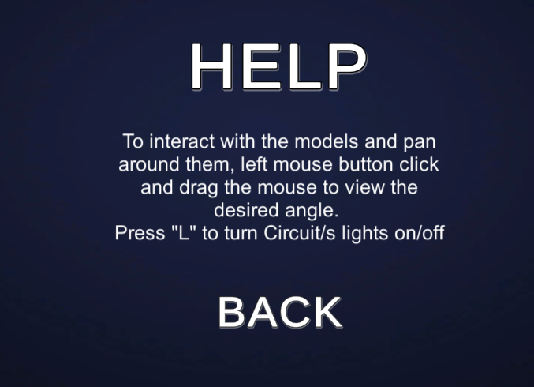

-The presentation of the "Help Menu" text however could be improved slightly by spacing out the various tips/guides from one another for better discoverability

-Exiting the game is simple and can be done by clicking on the Exit on the main menu, which closes the game/application or quit in the pause menu.

Desirable –

-The Text is clean white with a blue gradient background, this is pleasant to look at, although relatively basic. However, this adds to its simplicity.

-Pause menu when hitting ESC (Escape Key) is slightly smaller than the screen size and shows a slight portion of the level behind it.

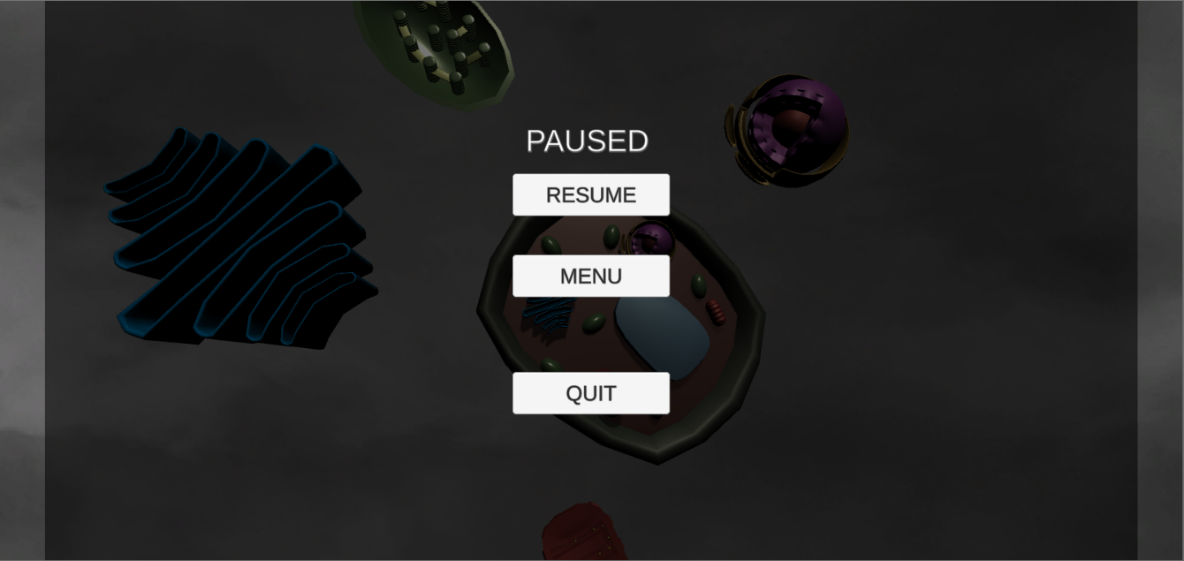

-Light model is clear to view and provides an audible "click" when you interact and switch the light on (by pressing the "L" Key)

-Lights display and bright interactive light that lights the rest of the model properly.

Findable –

-After Clicking play, the ability to return to the main menu is clearly visible at the bottom portion of the screen, with all the scientific resources/ models clearly displayed in the centre,

under the direction of "Select a 3D Model" this allows me to understand that the menu I am in is the model selection screen.

-Toggling the light switch is done by hitting the "L" Key, which some users may not know immediately as the instructions are in the help menu.

# Amendments made from the UX testing:

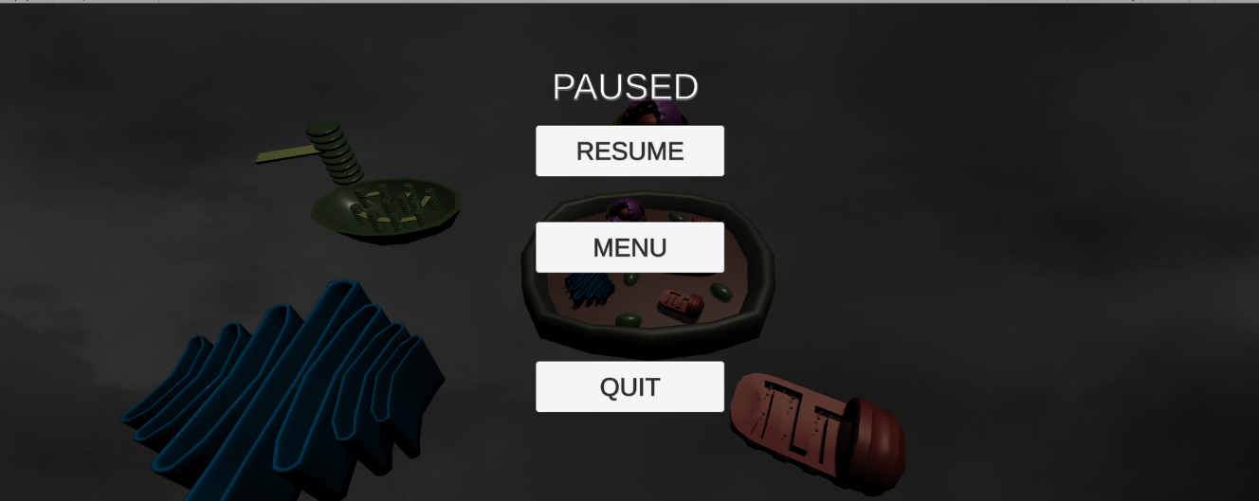

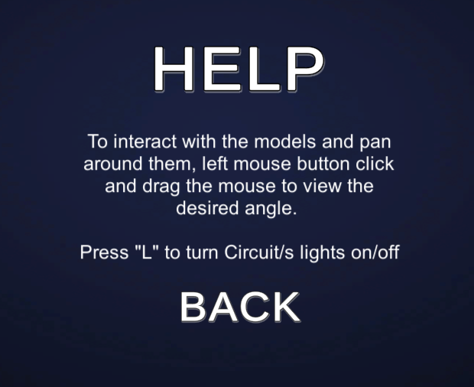

# End-user documentation –

## Main menu

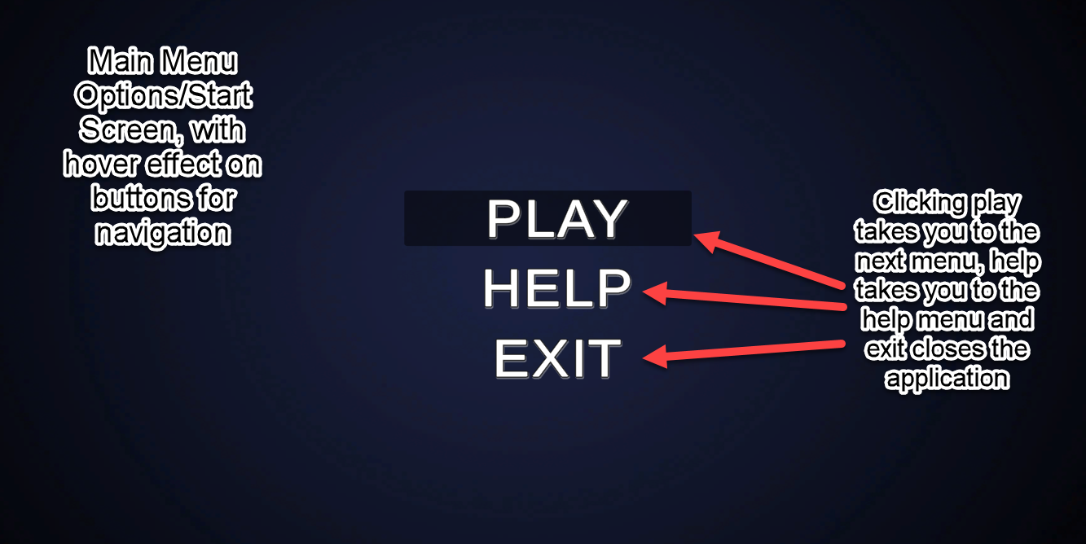

## Help menu

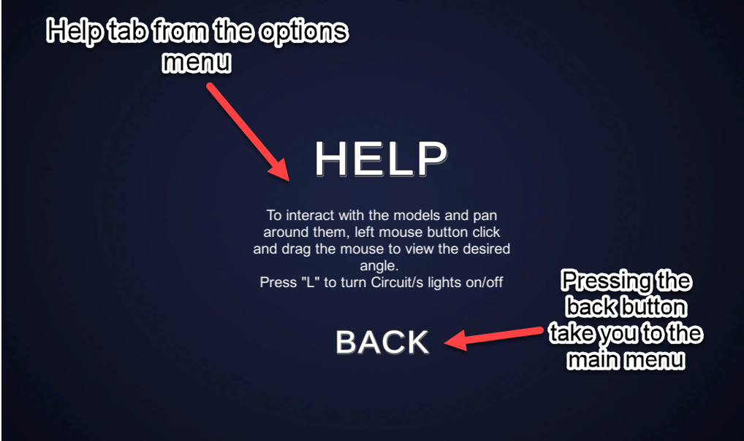

## Exit Button

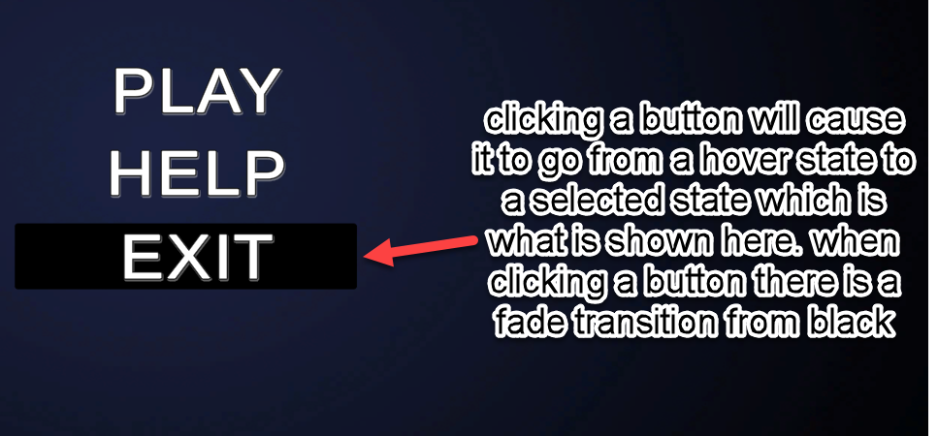

## Choice menu (plant cell)

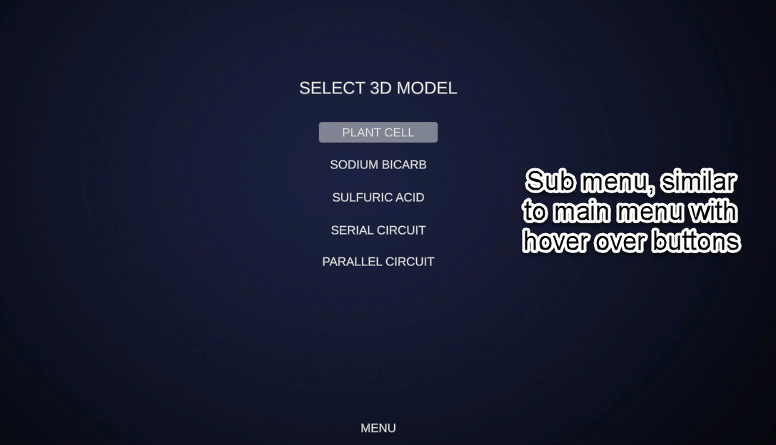

Plant cell 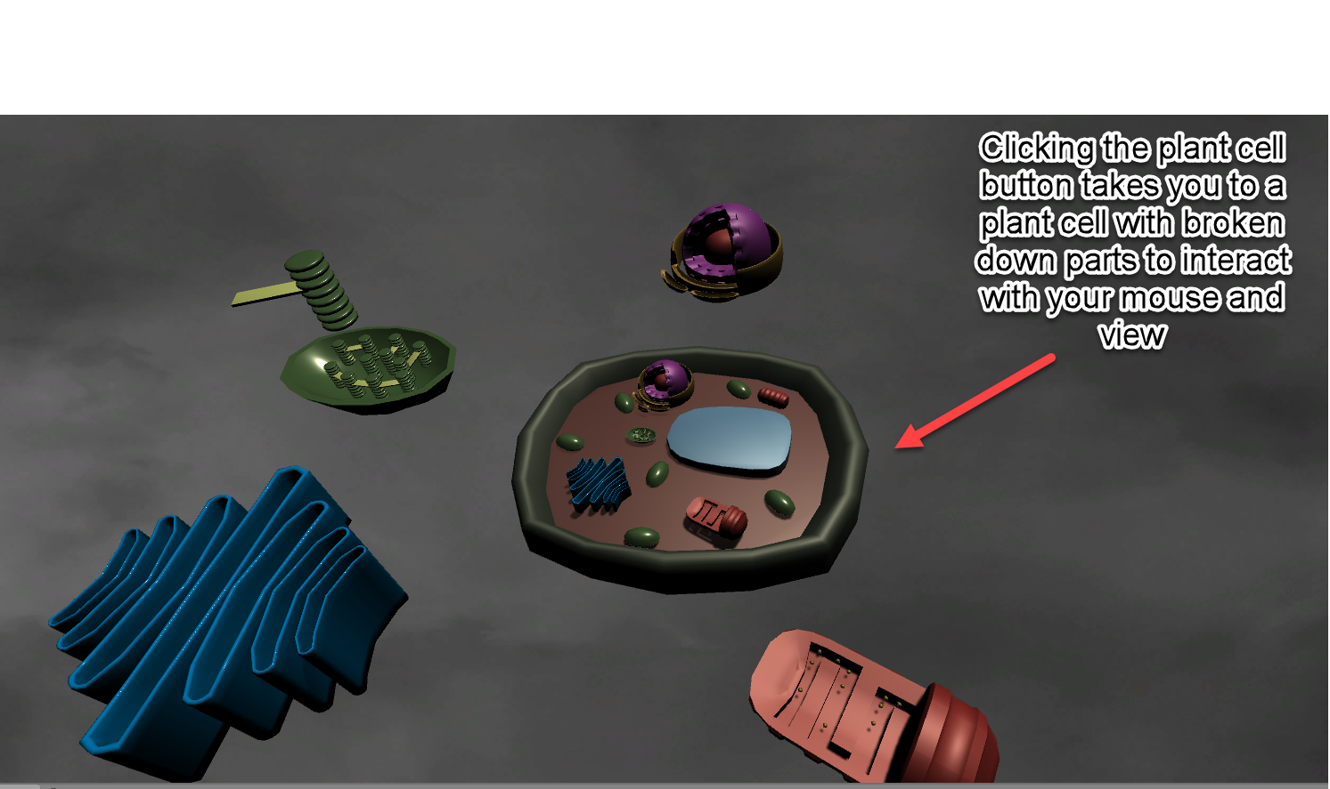

## Pause menu

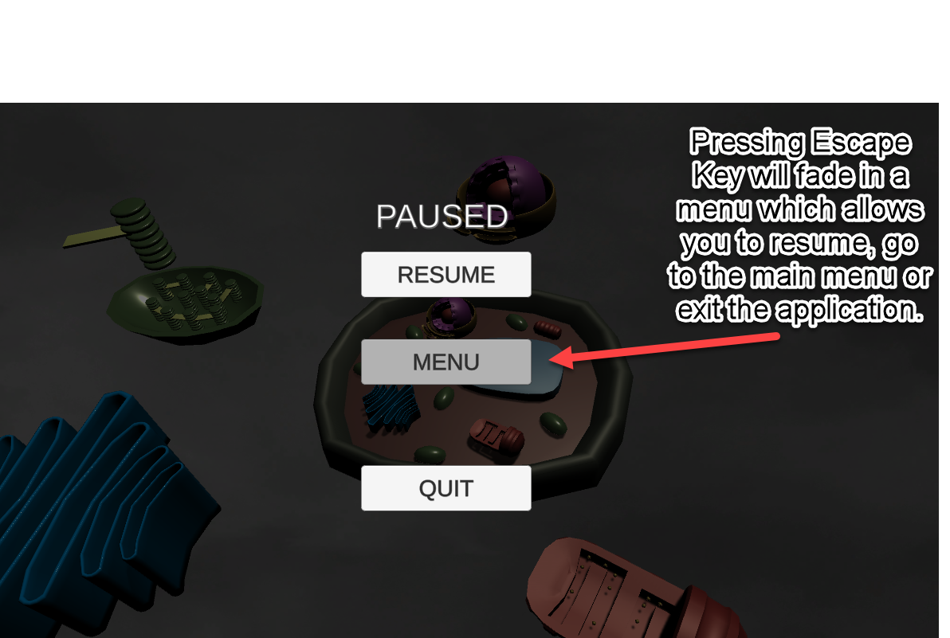

## Choice menu (sodium bicarbonate)

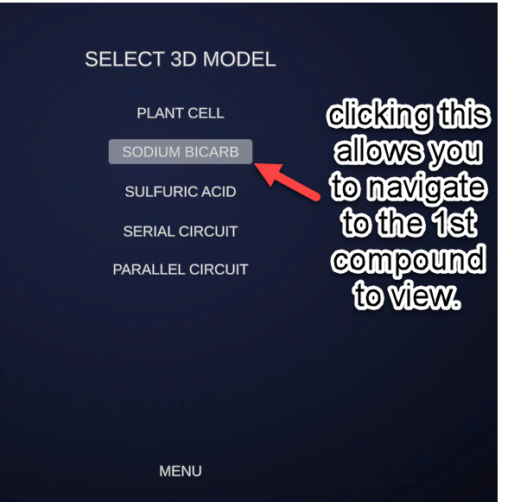

## Sodium Bicarbonate

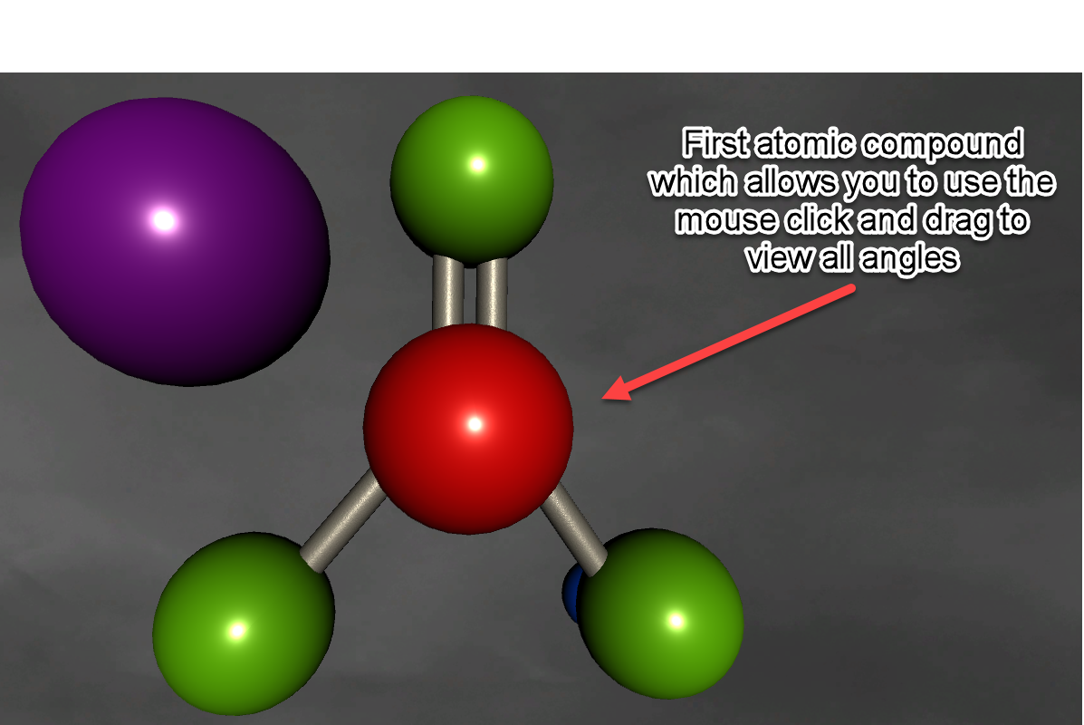

## Choice menu (Sulfuric Acid)

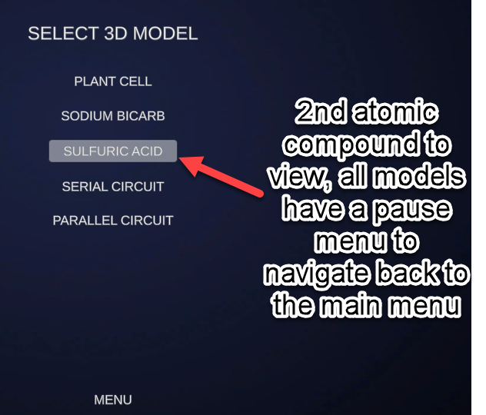

## Sulfuric Acid

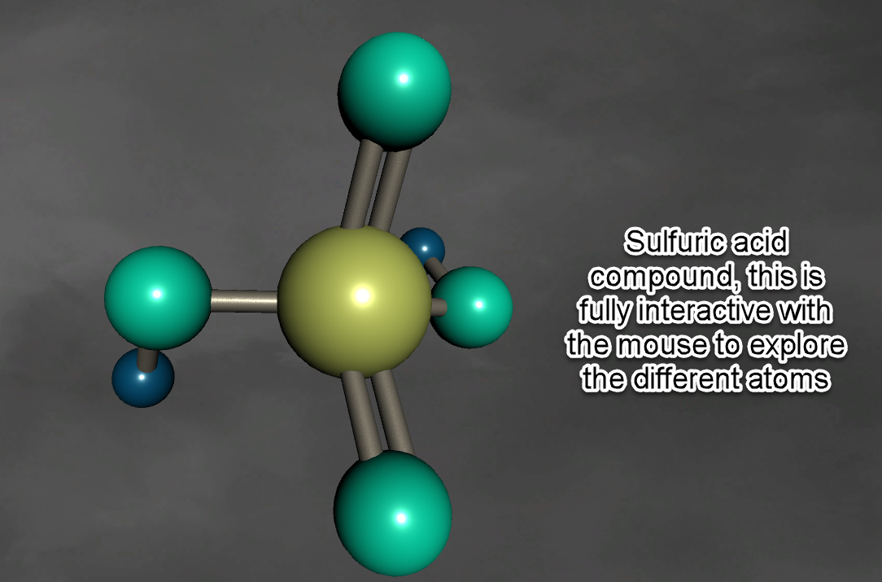

## Choice menu (Serial circuit)

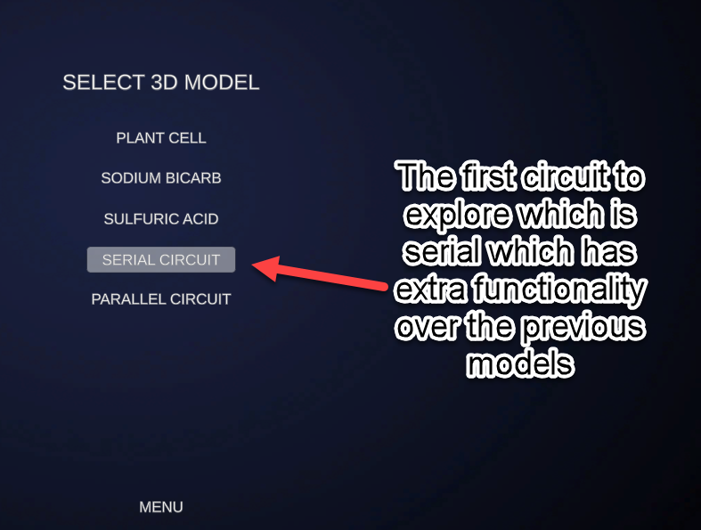

## Serial circuit (no light)

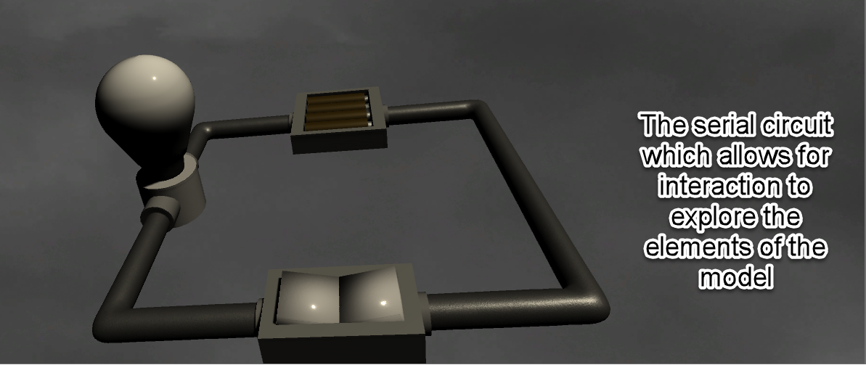

## Serial circuit (lights on)

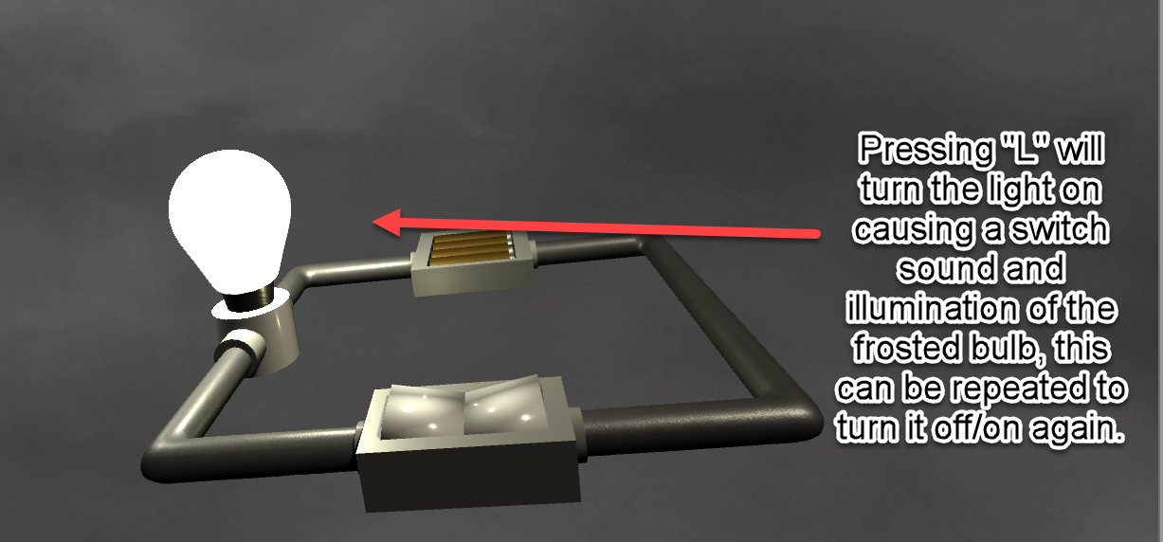

## Choice menu (Parallel circuit)

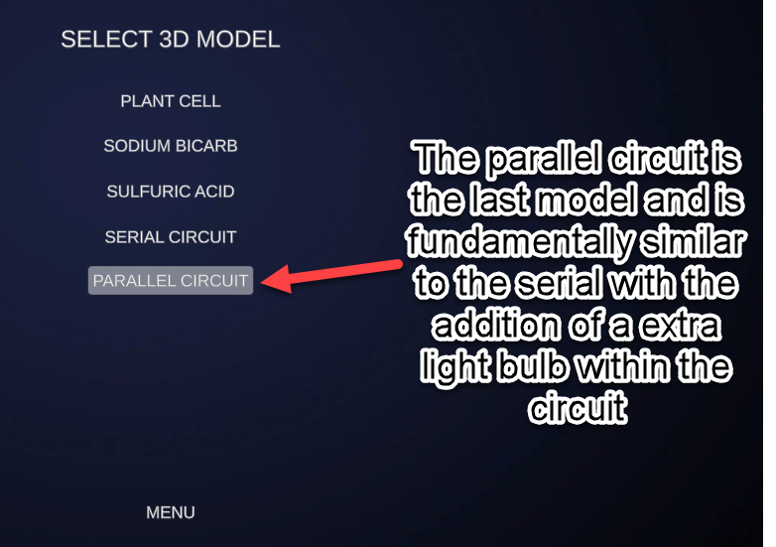

## Parallel circuit (no light)

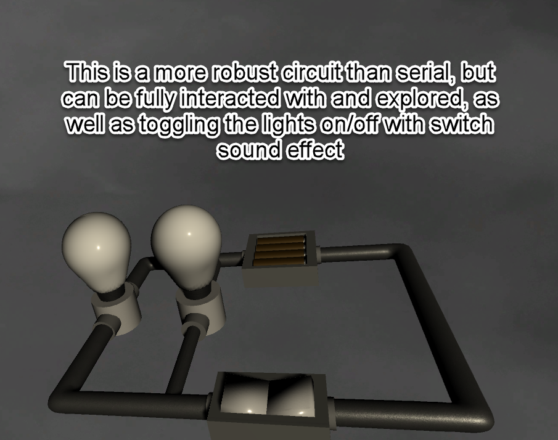

## Parallel circuit (lights on)

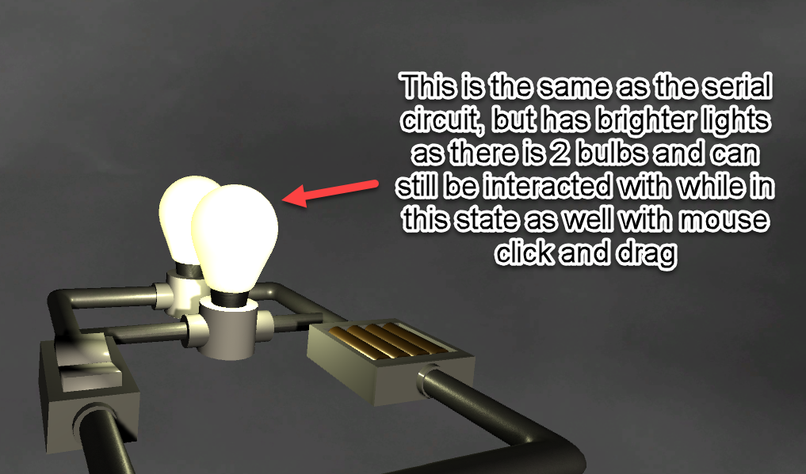

# Evaluation–

The completed visualization of the project in comparison to the requirements extruded from the scenario, this evaluation will highlight the how the completed project has turned out and what requirements.

## Functional Requirements

**Viewing the model,** with the completed visualization of the application, this was at the forefront of the development and heavily depended on it, without this the project would be useless and cease to function. To compare this requirement to the completed project. The model can be clearly seen easily with a neutral backdrop so keeping focus on the model.

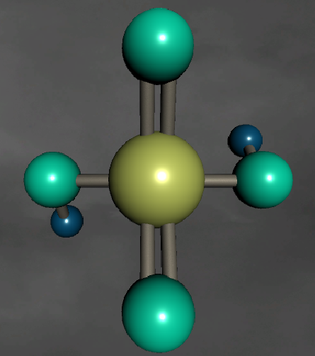

**Interaction with the model,** was an important part within the development and making sure it achieved the desired results. This has clearly been met to a good standard, but in a newer iteration of the application further interaction could be implemented such as a zoom in function or breakdown of the models completely. It achieves the requirement but does not go beyond it with further functionality.

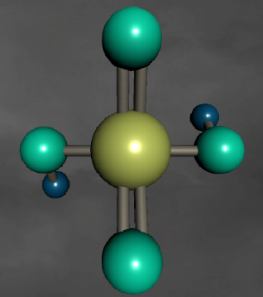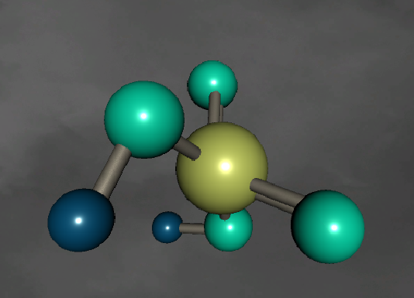

**Menu navigation,** in comparison to the completed project this has been met in a simplistic but intuitive way which allows first time users to easily grasp the navigation of the completed project. It could go into greater depth but that could affect the overall user experience with could reduce the likeability or functional use dependant per user. The overall graphical side of the menu is simple and clean but could go into a deeper design adding animation effect which would make it more appealing to more users, but it meets the requirements and does it simply and concisely. This ties into keeping the interface simple within the UX requirements, alongside keeping the overall consistency of the menu systems relative which allows for a theme to emerge, however this could be executed better to create a full theme between the main, choice and pause menu which could be improved in future versions.

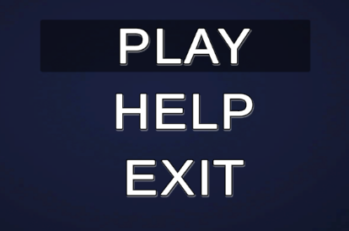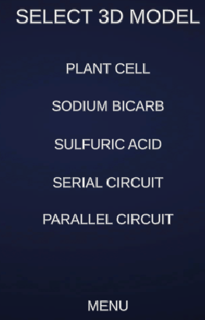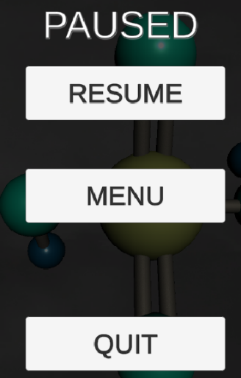

**Clear way to quit the application,** this has been clearly met as both the main menu and pause menu both allow for the exiting of the application which a simple click of the button, there is no conformation system to make sure it was purposeful which could be made in a future version.

## Non-Functional Requirements

**To transition from one screen to another,** a fade transition is applied to all scenes which goes from black to transparent to reveal the scene, it fulfils it purpose but more complexed transition could be implemented. However, it achieves a transition regardless.

**Strategic use of colour and textures,** a multitude of textures have been used to display the models in a presentable fashion alongside the use of colours has been implemented used to break up each individual component of the models.

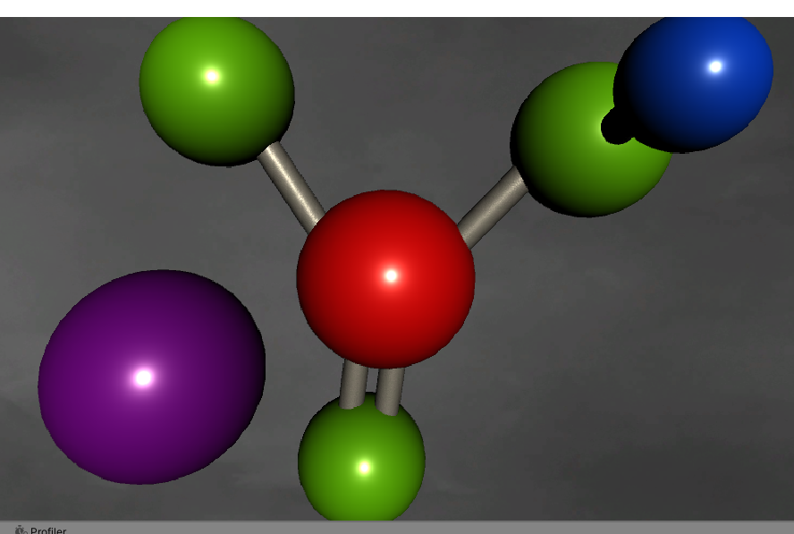

# Annotated code to achieve this –

## Main menu

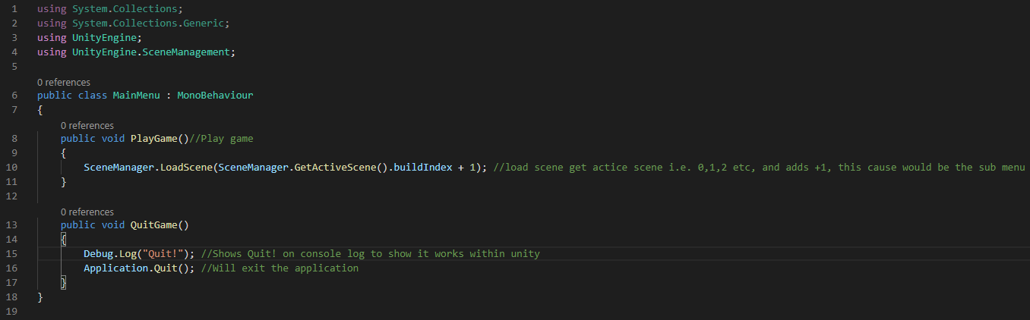

## Sub menu/choice menu

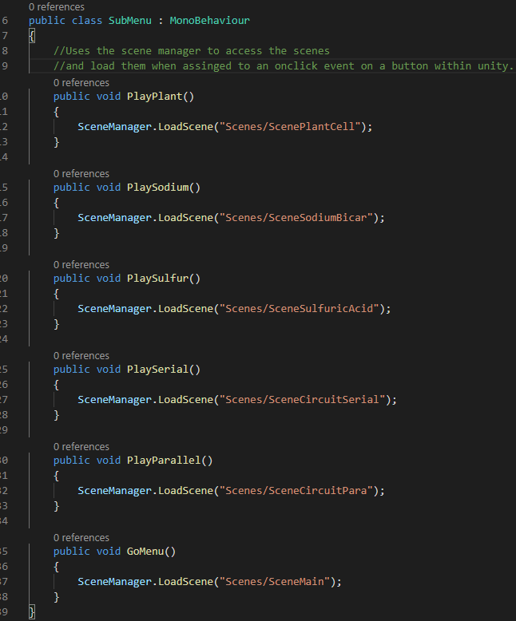

## Fade transition

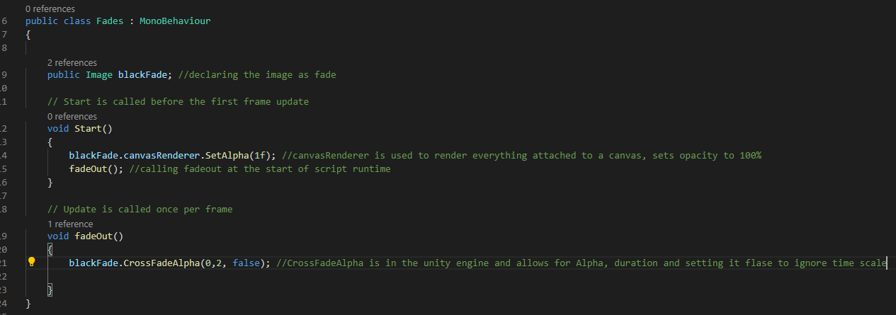

## Rotating object/s

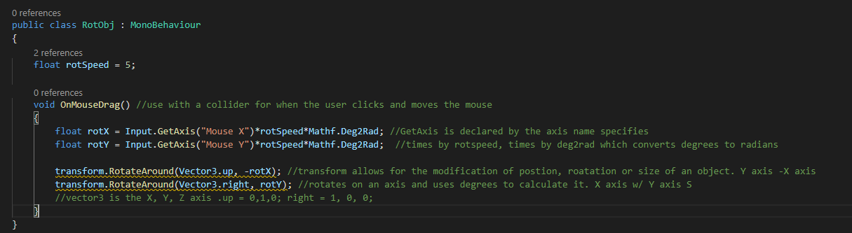

## Audio script

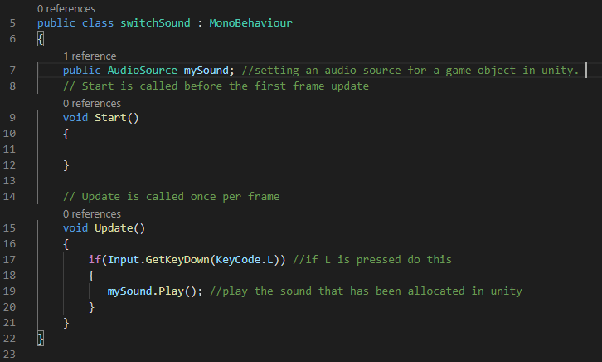

## Toggle lights on/off 1

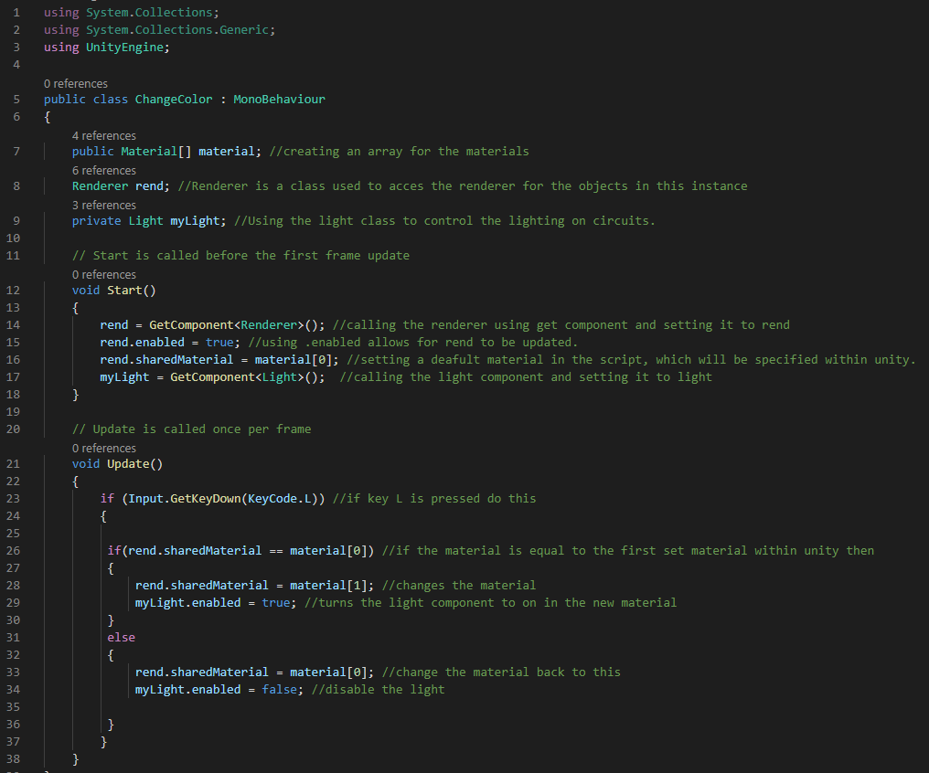

## Lights on/off 2

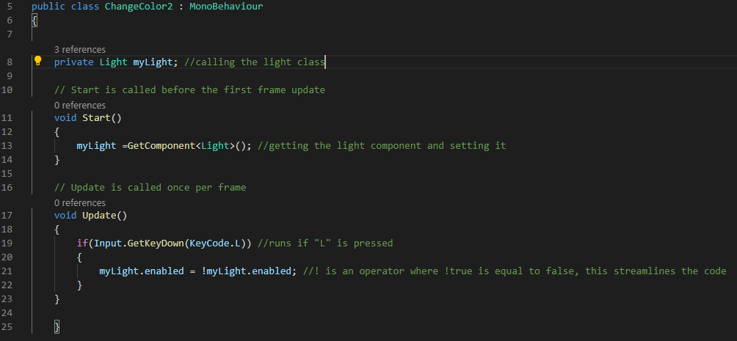

## Pause menu

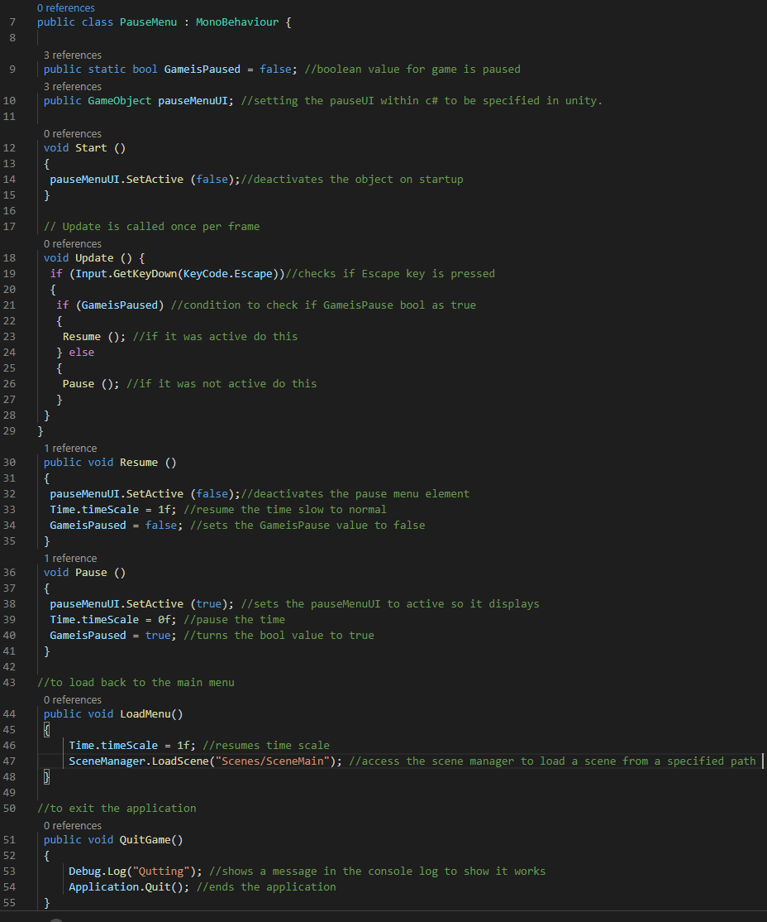

# Evaluation of tools and methodologies –

## Tools –

### 3ds Max

-introduction Autodesk 3ds Max is an industry standard modelling tool which is used widely by both students and professionals for creating renders, modelling and adding animations.

-Modelling 3ds Max is one of the best modelling software’s out here due to a lesser learning curve per say to Zbrush which focuses on sculpting. It has many features to be able to manipulate objects to the desired state or importing models and modifying them to get the perfect vision. The use of grouping objects as well as setting material to individual objects allows for greater manipulation alongside the creation of UVW maps and smoothing groups to make the model curves smooth over all polys. However, it has limitations such as its learning curve, handling of complex models is difficult within 3ds Max. (UVW Map Modifier | 3ds Max 2017 | Autodesk Knowledge Network, n.d.), (New 3ds Max Features 2021 | 3D Modelling & Rendering Tools | Autodesk, n.d.)

-exporting 3ds Max exports is extremely simple and allows a diverse choice of file formats to export from i.e. .obj or .fbx these will export will its saved groups which is handy for keeping the model in its separate sections and exporting from 3ds Max is relatively quick without hindrance.

Overall 3ds max has helped the creation of the final product greatly and has allowed for many elements within the model to be streamline or simplified, although its has great uses it does has minor set back but a high recommend choice when making anything 3ds or manipulating models.

### Substance Painter

This is a software made by Adobe and is heavily used in the games and film industry for painting of material on 3d models, fundamentally like photoshop with masks. importing into substance painter allows you to choose a pre-set applications and dimensions for the textures i.e. 1024, 2048 etc. and an AI unwrap.

-creating maps if maps have not been created, they will be automatically created when importing into the substance painted. However, the topology is not the greatest when importing

-texturing applying to the material to models is very straight forward as sections can be masked off and the material/s directly applied and then modify it to the means you want, or they can be painted on. This has a learning curve; it is easy to use but hard to use to its fullest potential. Overall, it is a useful tool with little to criticize other than the control scheme of the application.

-exporting the exporting of textures once baked provides a wide array of choices for all platforms, to export to unity to create material on the model with maps you have to create an ambient occlusion map for the lighting alongside project must be set up with PBR metallic smoothness. (Substance Painter - Features, n.d.)

### Unity

-creating 3D application, importing into unity as well as setting scenes up is extremely easy with relatively little work, canvas can be used for UI elements and attaching spirts to game objects and getting them to function is extremely easy. Overall, this is a common choice for smaller developers due it is free to use, and easy to get the grasp of with endless possibilities when making a game. Overall, unity is a great software and engine.

-testing within unity testing is both easy and difficult, profiler can be used to measure resource usage and assembly definitions can be used to create test cases which is very complexed. However customisable to user need which is useful. (Technologies, n.d.)

## Methodologies –

Agile is the methodologies which was used throughout the project, due to many iterations on each section of the project progressively adding features and functionality which was done in daily time frames.

what agile methodologies, a mix of agile and scrum was used, scrum used for daily sprints which consolidated to what needs to be done the next day. Due to using agile there is an inherent benefit with the use of daily testing and iteration, which helps identify problems and plan fixes on them while still well know opposed to being forgotten. Working as an individual/small team agile is very flexible to fit the purpose and needs of the project which is why it was implemented. (Moniruzzaman & Hossain, 2013), (Schwaber & Sutherland, 2018)

# References

Hunt, N., Renner, C., Embry, B., Wright, D., Myers, J., Arias, L., Barron, J., Webb, P., Prentiss, R. and Rodis, J. (2016) FUNCTIONAL And TECHNICAL REQUIREMENTS DOCUMENT FDP Expanded Clearinghouse Pilot Phase 2 – Web-Based System, [Online]. Available at <https://sites.nationalacademies.org/cs/groups/pgasite/documents/webpage/pga_179129.pdf>.

Moniruzzaman, A. and Hossain, D. (2013) Comparative Study on Agile software development methodologies, Global Journal Of Computer Science And Technology (C) Version I, vol. Volume 13, no. Issue 7, .

New 3ds Max Features 2021 | 3D Modelling & Rendering Tools | Autodesk (n.d.) Autodesk.Co.Uk, [Online]. Available at <https://www.autodesk.co.uk/products/3ds-max/features?plc=3DSMAX&term=1-YEAR&support=ADVANCED&quantity=1>.

Schwaber, K. and Sutherland, J. (2018) Scrum Guide | Scrum Guides, Scrumguides.Org, [Online]. Available at <https://www.scrumguides.org/scrum-guide.html>.

Substance Painter - Features (n.d.) Docs.Substance3d.Com, [Online]. Available at <https://docs.substance3d.com/spdoc/features-28737551.html>.

Technologies, U. (n.d.) Unity Platform, Unity, [Online]. Available at <https://unity.com/products/unity-platform>.

User Experience Basics | Usability.gov (n.d.) Usability.Gov, [Online]. Available at <https://www.usability.gov/what-and-why/user-experience.html>.

UVW Map Modifier | 3ds Max 2017 | Autodesk Knowledge Network (n.d.) Knowledge.Autodesk.Com, [Online]. Available at <https://knowledge.autodesk.com/support/3ds-max/learn-explore/caas/CloudHelp/cloudhelp/2017/ENU/3DSMax/files/GUID-78327298-4741-470C-848D-4C3618B18FCA-htm.html>.